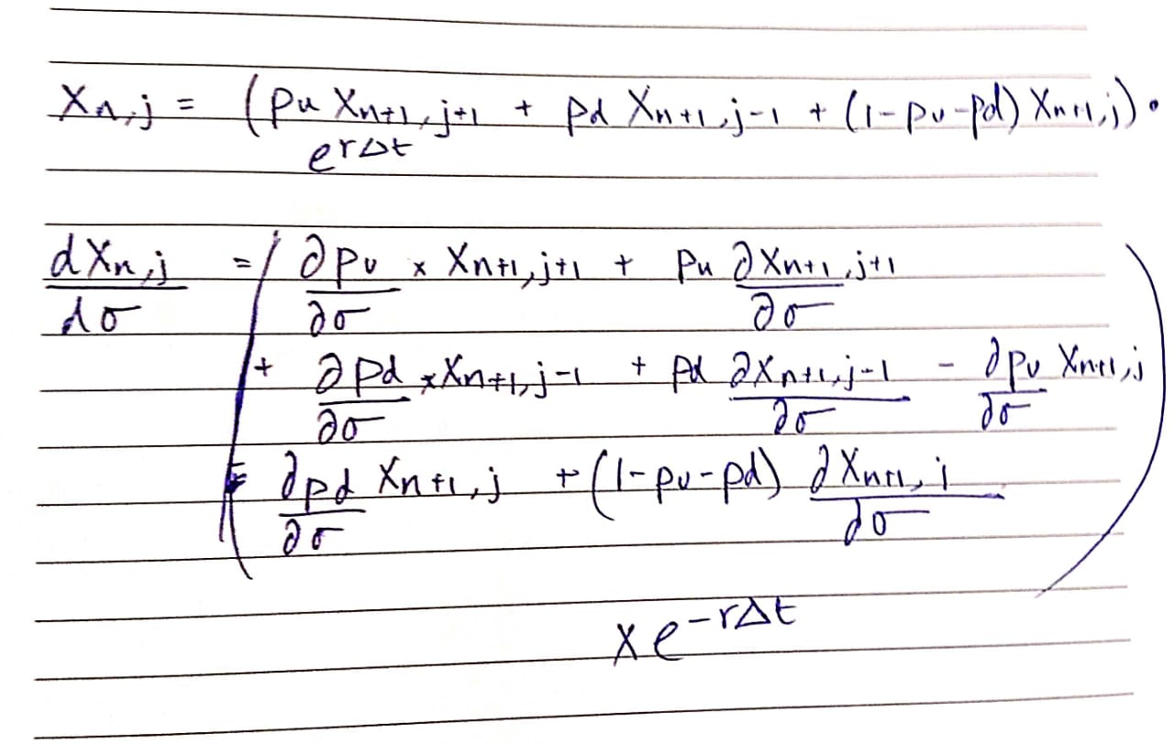

These are the formula that I used to calculate the values of X_t_d and dX_t_d/dsigma

In part a) I have a list called Costs which contains the possible values of X on t_e

Next we step by step backtrack on Cost list until it contains only one element which is the value of X_t_d

In part b) I do the exact same steps as in price_xyz but I have a new list called differentiations.

Initially differentiations has the following value for each leaf node:

{dA_t_e/dsigma if A_t_e > B

{0 otherwise

A_t_e = A_t_d * e^(i*sigma*∆t), So calculating the values of differentiations is pretty straight forward.

Next we calculate dp_d/dsigma and dp_u/dsigma which is a little tedious to calculate but easy to execute.

Now we again just backtrack on the two lists till only one value is left in differentiations